COMPANY: WEB SELLER PRO LIMITED
DOCUMENT: TEST STRATEGY
VERSION/DATE: v1.00 August 2024.

Contents
1 Document Control 4
1.1 Document Revision History 4
2.0 Introduction 5
2.1 Purpose 5
2.2 Project Overview 5
3.0 Scope of Testing 6
3.1 In Scope 6
4.0 User Stories & Test Reference Data 6
5.0 Test Approach 7
5.1 Functional Testing 7
5.1.1 Unit Testing 7
5.1.2 Bug Regression Test 7
5.1.3 User Acceptance Test 8
5.1.4 Regression Test 8
5.1.5 Smoke Testing 9
5.1.6 Integration Testing 9
5.1.7 System Testing 9
5.2 Non-Functional Testing 10
5.2.1 Performance Testing 10
5.3 Proposed Test Environment 10
5.4 Test Tools 10
5.5 Test Preparation 12
5.5.1 High level Test Scenarios 12
5.5.2 Test Scripting 12
6.0 Test Schedule 13
6.1 Test estimates 13
6.2 Milestones 13
Dependencies/Assumptions/Constraints/Risks 14
6.2 Dependencies 14
Test Deliverables 15
7.0 Defect Management 15
8.0 Signoffs 16
9.0 APPENDIX A – WEB SELLER PRO LIMITED QUALITY ASSURANCE PROCESS 17

1 Document Control
Distribution/Review List
Role | Name | For Review/Information | Approval required Y/N
Dev Lead
Product Owner
Scrum Master
Developer
Developer
Developer
Developer
Tester

1.1 Document Revision History
Date | Issue | Author | Details of Change
26/07/2024 | 0.1 | Tosin Adeleye | Draft document created
08/08/2024 | 0.2 | Tosin Adeleye | Draft Document edited

2.0 Introduction
This document outlines the approach, objectives, and resources required for testing company’s software applications. It serves as a blueprint for the testing process, detailing how testing will be conducted to ensure that the software meets its quality standards and requirements.

2.1 Purpose
This document provides a structured and organised approach to software testing. It outlines the framework and principles that guide the testing process using the Software Testing Life Cycle process.

2.2 Project Overview
The following schematic depicts the Web Seller Pro Limited quality assurance strategy for new software being introduced into production. (A blown-up view is shown in Appendix A.)
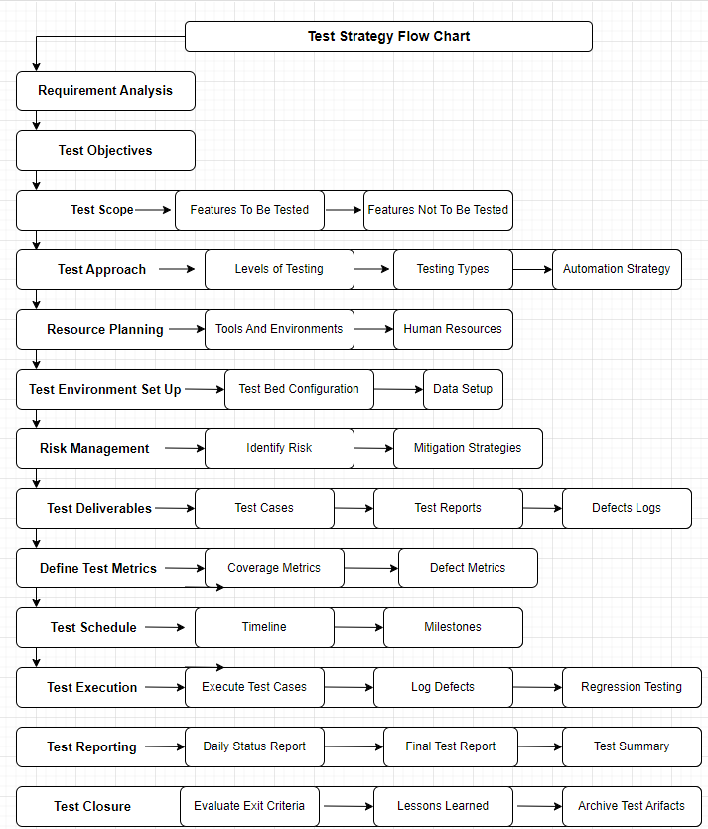

The process incorporates the following features:
Use of Testing Automation – The programme effectively leverages testing automation, with daily runs conducted across all test environments beyond the Development stage. This practice substantially enhances the system's robustness. By identifying potential issues early, it minimizes the risk of human error and reduces costs associated with manual testing. This proactive approach ensures that changes in one part of the system do not inadvertently impact other areas, maintaining overall system stability and reliability.
Multiple UAT Environments – The test process supports multiple UAT environments enabling more than one enhancement to be streamed independently.
Code Merge – On completion of UAT in any environment, a code merge function will merge the confirmed software elements with all system components approved for production use. The merged code is placed in a Pre-Production environment where automated testing is conducted to assure compatibility of all elements.

3.0 Scope of Testing
This section defines the list of functional and non-functional requirements which are in scope and out of scope for the testing as agreed between the Project’s Stakeholders.
  - In Scope
The system to be tested is defined formally as all software developed to meet the agreed Statement of Work for the project with any further agreed scope adjustment. The In-Scope Items include:
- Functional Areas: Specifies the specific functionalities, features, and modules that will be tested. This includes user interactions, business logic, and data handling.
- Non-Functional Areas: Includes aspects like performance, security, usability, compatibility, and compliance that will be tested.
- System Interactions: Defines the interactions with other systems, applications, or external interfaces that need to be tested.
- User Roles and Permissions: Specifies the testing of different user roles, access controls, and permissions.
4.0 User Stories & Test Reference Data
User stories for both of the key elements of the system are Documented in Zoho Drive and these are the formal expression of the required functionality to be explored and verified in testing.
Note also that there is a business requirement to capture statistics on performance & availability. These are detailed in the document Performance Requirements in Zoho Drive.
In order to understand the requirements for the application, prepared some outline user stories depicting the customer experience targeted and explaining the roles of various aspects of the system will be created, which will be linked to this document for traceability.

5.0 Test Approach
This section gives an overview of the types of testing to be performed and the entry and exit criteria for these test phases, identifies the testing tools, test environment, test server and test data to be used for the testing of the project.
  - Functional Testing
5.1.1 Unit Testing
Unit testing will be performed by development to prove any code they have created is at a suitable level to enter System Test. The code should be stable and perform basic tasks such as updating the database tables and communicating with other servers or systems.

Entry Criteria | See Development Plan criteria
Exit Criteria | Code has version control in place.
Exit Criteria | No known major or critical defects preventing module moving to Product testing.
Exit Criteria | Known defects are reported and made available.

The Testing will be done using the Dev Local Test Environment
Benefit: Testing carried out on the Dev Local Environment will prevent any unwanted changes to be pushed into the Main Dev Test Environment.

    - Bug Regression Test
This testing will be done by the Web Seller Pro Limited Testers. Each time a defect is fixed, the potential exists to inadvertently introduce new errors, problems, and defects. An element of uncertainty is introduced about ability of the application to repeat everything that went right up to the point of failure. Hence after the defect fixes, the existing functionalities will be regression, tested to ensure that there are no major defects in the applications due to the defect fixes.

Entry Criteria | Unit, and System testing has been completed.
Entry Criteria | Outstanding issues and defects have been identified and documented.
Entry Criteria | Test scripts and schedule are ready.
Entry Criteria | The testing environment is available.
Exit Criteria | All systems involved passed regression testing and meet agreed functionality requirements.
Exit Criteria | Outstanding defects have been identified and documented.

    - User Acceptance Test
This test is to ensure that the system meets the needs of the Organization and the end user/customer. It validates if the system works as mentioned in the User Story document. This testing will be done by the Web Seller Pro Limited Testing Team (Project).

Entry Criteria | Business requirements have been met
Entry Criteria | UAT scripts are ready for execution.
Entry Criteria | The test environment is available.
Entry Criteria | Test resource has been made available for the duration, to support UAT.
Entry Criteria | Test Data is available
Exit Criteria | For Web Seller Pro Limited QA Test Team to document in their UAT Test Strategy

    - Regression Test
The final regression testing will be carried out by the Web Seller Pro Limited Test Team on Final staging environment. Prior to putting code live a merge build is created by merging live web/App code with the signed off development build. A series of regression tests are carried out on this build to confirm the new code is still functioning correctly and all other existing live functionality is still working. Various meetings are held during this phase with a final Go/No-go on the last scheduled day to decide if the final merged build is ready to go live
Entry Criteria | Unit, System, UAT and Integration tests has been completed.
Entry Criteria | Outstanding issues and defects have been identified and documented.
Entry Criteria | Test scripts and schedule are ready.
Entry Criteria | The testing environment is available, with the merged build deployed
Exit Criteria | All testing (automated and manual) is complete and signed off
Exit Criteria | Outstanding defects have been identified and documented.

    - Smoke Testing
Smoke testing will be done on to ensure that the system is ready to test on each of the major code deployments. This will be carried out by testing team when there is a release/deployment of any major functionality.

    - Integration Testing
Integration testing will be performed by Web Seller Pro Limited testing team. This is to ensure that the integration of the individual components and the connectivity to the environment is accurately working. Integration testing on applications and database systems will be covered as part of system testing.

    - System Testing
The key system testing areas are listed below:
Usability Testing - An appropriate amount of usability testing will be undertaken during the SIT phase to determine if the user experience of the web pages is steady flowing.

Installation Testing - The lead developer will ensure each new website build is applied to the test server(s) prior to each test phase.
Compatibility Testing - A select few handheld devices will be used during System Testing. This will provide coverage and compatibility assurance whilst testing on the most widely used handheld devices on the market.
Operating systems Include:
- iOS
- Android
- Windows
- Linux

Orientation Testing - All device testing will be performed in Landscape and Portrait orientations, minimising any inconsistencies in design and layout.

5.2 Non-Functional Testing
This section gives details on the non-functional testing carried out as part of project.
    - Performance Testing
The purpose of this testing is to understand the strength of the application in terms of Load/Stress. Load/Stress Testing requirements are defined in the Performance Requirements document. The required stress tests are detailed therein and data to be collected in terms of availability and response statistics are also defined there.
Measuring the responsiveness of the system under a given load to determine if the non-functional requirements have been met.

  - Proposed Test Environment
The following are the proposed environments for the testing process
- PostMan
- Microsoft Visual Studio
- Microsoft SQL Server Management Studio
- Zoho

  - Test Tools
The testing tools used by testing team for the project are listed below
The automation framework will integrate and make use of the following tools:
 | Zoho (Visual Studio Team Services (VSTS)) – This cloud-based solution is where test cases, defect management, test management, and the product backlog will be hosted and made accessible for testing.
 | Specflow – This tool is used to define, manage and automatically execute human-readable acceptance tests in .NET projects. Writing easily understandable tests is a cornerstone of the BDD paradigm and also helps build up a living documentation of your system.
 | NUnit - Is an open-source unit testing framework for Microsoft .NET. NUnit has been important in the development of test-driven development and can be used to run tests in parallel.
 | RestSharp - Is a comprehensive, open-source HTTP client library that works with all kinds of .Net technologies. It can be used to build robust applications by making it easy to interface with public APIs and quickly access data without the complexity of dealing with raw HTTP requests.
 | Selenium WebDriver - WebDriver is a tool for automating web application testing, and in particular to verify that they work as expected by interacting with browsers using a friendly API that's easy to explore and understand.
 | PostMan – This tool is for testing, and debugging APIs (Application Programming Interfaces). It provides a user-friendly interface that allows testers to interact with APIs by sending requests and viewing responses without needing to write code.
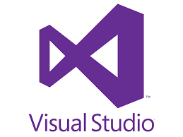 | Visual Studio - This is the Automation Test Environment where the test script will be written and executed.
 | GitHub – This is a web-based platform that provides hosting for software development and version control using Git. It will be used to integrates version control with a range of tools for collaboration, project management, and code review.

  - Test Preparation
5.5.1 High level Test Scenarios
The high-level test scenarios are derived from the User story document. The test scenarios should be reviewed and signed off before starting with the test case scripting activity.

5.5.2 Test Scripting
The Test Scripts will be written by the Tester. These scripts will be derived from the signed off high level test scenarios
The scripts will be prioritised in order of requirement and will include the priorities below. All P1 scripts will take precedence during insinuating circumstances.
Priority | Guidelines
1 – High | Failure or a no-run of this test is critical – it must be successfully executed before the next test sprint commences or a GO decision can be made for live.
2 – Medium | Failure or a no-run of this test is likely to result in loss of functionality but a business work around can be put in place if it is not successfully executed; although every effort should be made to execute tests with this priority assigned.
3 – Low | Failure or a no-run of this test will not degrade productivity if not successfully executed and the loss of functionality is not critical to the business.

6.0 Test Schedule
This outlines the specific activities, milestones, and deadlines associated with the testing phase of a software development project. It is a critical component of the overall test planning process and helps ensure that testing is conducted in a systematic, organized, and timely manner.

6.1 Timeline (Test Estimates)
The following extract from the project plan defines the targets for test execution in the project duration.
Active milestones for testing will be determined by the project plan, which should evolve over time and should not require an amendment to the Test Strategy document.

6.2 Milestones
Standard milestones involved in testing are as follows:
Milestones
Test Plan Creation
Test Script/Case Creation
Test Data creation
Unit Testing
API Testing
Integration Testing
Retesting
Regression Testing
System Testing
UAT Testing
Code merge - Regression Testing
Functional Pilot Live release

Dependencies/Assumptions/Constraints/Risks

6.2 Dependencies
Dependency | Potential Impact of Dependency | Status
N/A

6.3 Assumptions
The following are the assumptions to start with testing activities
Assumption | Impact of Assumption | Status
Optimisation of Test Scripts across devices has been considered. | Considering the functionality and time scales we are not going to test all the functionalities across all the devices
We assumed UAT will Test all the content related tasks on desktop. | The content will be tested in UAT.
In subsequent Tests we will not Re-Test the repeated functional Tests instead we will test on defects. | The defects will be verified across each device and we will not test the entire functionality on all the devices which will be covered in Regression Testing.

6.4 Constraints
Constraints | Impact of Constraint | Status
Unavailability of Developer | No application developed for testing

6.5 Risks
Risk | Potential Impact of Risk | Mitigation Plan | Status
The time allocated for testing may be compromised due to the development/implementation delays | There might be impact on the testing schedule and the Project schedule | Test cases will be executed based on the Priority.  Additional testers might be added if required.
Concurrency – Manual testing of simultaneous transactions may not be able to completely prove the functionality. | Issues with simultaneous transactions might not be fully identified during system testing. | Can use a performance tool to test this functionality in full.

Test Deliverables
Test Deliverable | Description
Test Scripts | Testing team will be responsible for the system test Cases. Test Cases are reviewed in conjunction with User Story by Project Manager.
Traceability Matrix | The test cases are mapped to the User stories to ensure test coverage.
Test Execution | Test scripts executed should be updated with appropriate statuses and screenshots.
Test Progress report | The test Lead will be providing the status of test execution on a daily/weekly basis to the Developer Lead and the relevant project team.
Defect Report | All the defects logged during the testing cycle shall be documented and reported in timely manner for the defect Triage calls.
Test Exit Report | Test scripts, execution results, defect report with risks (if any) for go-live will be documented and provided to the stakeholders at the end of test execution.

7.0 Defect Management
Zoho will be used to log and track defects. Development team will have access to Zoho and will have full visibility of defects raised during test execution.
The Test log allows the test analysts to track the progress of all defects. The Defect Log records: ID, Open/ Closed, Test, Description, Priority, Assigned to, Assigned date, Expected Close Date, Closed Date.
Defect History will be updated with comments detailing Resolution/failure and then re-assigned to the appropriate person with the correct status.
8.0 Signoffs
The undersigned acknowledge they have reviewed the Test Strategy for Project and agree with its contents. The Agile Project Manager may proceed with execution of the project as per the information in this Test Strategy.
Completion/signoff is required prior to the start of testing activity.

Approvers List:
Role: | Name/Title: | Date:
Developer Lead
Developer
Developer
Developer
Developer
Tester Lead

9.0 APPENDIX A – WEB SELLER PRO LIMITED QUALITY ASSURANCE PROCESS

